COLLEGE / UNIVERSITY PROJECT REPORT

🎯
QuizMaster
An Online Quiz & Assessment Platform
Built with Flask · SQLite · HTML5 · CSS3 · JavaScript
A Project Report Submitted in Partial Fulfilment of the
Requirements for the Degree of
Bachelor of Technology in Computer Science & Engineering
Submitted By
Tarun Kumar
Roll No. / Enrollment No.: [Your Roll Number]
Under the Guidance of
[Guide / Supervisor Name]

[Your College / University Name]
Department of Computer Science & Engineering
July 2026

Certificate
This is to certify that the project report entitled “QuizMaster – An Online Quiz & Assessment Platform” is a bona fide record of the work carried out by Saksham Jha, in partial fulfilment of the requirements for the award of the degree of Bachelor of Technology in Computer Science & Engineering, during the academic year 2025–26.
The work embodied in this report has not been submitted elsewhere for the award of any other degree or diploma.

________________________  [Guide Name]  Project Guide | ________________________  [Head of Department]  HOD, Computer Science & Engineering

Acknowledgement
I would like to express my sincere gratitude to my project guide, [Guide Name], for their invaluable guidance, continuous support, and encouragement throughout the development of this project. Their insights were instrumental in shaping both the technical direction and the presentation of this work.
I am also thankful to the Department of Computer Science & Engineering at [Your College Name] for providing the resources and environment necessary to carry out this project.
Finally, I would like to thank my family and friends for their constant motivation and support during the course of this project.
— Saksham Jha

Abstract
QuizMaster is a full-stack web application that digitizes the process of conducting timed, objective assessments — the kind widely used by companies during recruitment and by colleges for internal evaluation. The system allows users to register, log in, and attempt randomized, timed quizzes across six technical categories: HTML, CSS, JavaScript, Python, DBMS, and DSA.
Each quiz is auto-graded on submission, with a countdown timer that automatically submits the attempt if time expires. Results are persisted so users can track their history, compare themselves on a leaderboard, and review a personal performance profile. A separate admin panel allows an administrator to add or remove questions and manage registered users, making the question bank fully extensible without touching code.
The application is built using Flask (Python) for the backend, SQLite for data persistence, and a hand-crafted HTML5/CSS3/JavaScript frontend — with no heavy frontend framework — to keep the project lightweight, transparent, and easy to extend. This report documents the objectives, design, implementation, testing, and outcomes of the project, along with screenshots of the working system.

Table of Contents
Chapter | Title | Page No.
 | Certificate | i
 | Acknowledgement | ii
 | Declaration | iii
 | Abstract | iv
 | Table of Contents | v
1 | Introduction | 1
1.1 | Background
1.2 | Problem Statement
1.3 | Objectives
1.4 | Scope of the Project
2 | Existing System vs Proposed System
2.1 | Existing System
2.2 | Limitations of Existing System
2.3 | Proposed System
3 | System Analysis
3.1 | Feasibility Study
3.1.1 | Technical Feasibility
3.1.2 | Economic Feasibility
3.1.3 | Operational Feasibility
3.2 | Software Requirement Specification
3.3 | Hardware Requirements
4 | System Design
4.1 | System Architecture
4.2 | Database Design
4.2.1 | Users Table
4.2.2 | Questions Table
4.2.3 | Results Table
4.3 | Module Description
4.3.1 | Authentication Module
4.3.2 | Quiz Engine Module
4.3.3 | Results & Leaderboard Module
4.3.4 | Admin Module
5 | Technology Stack
6 | Implementation
6.1 | Project Structure
6.2 | Features Implemented
6.3 | Core Logic Highlights
6.3.1 | Randomized Question Selection
6.3.2 | Server-Side Grading
6.3.3 | Timer & Auto-Submit
7 | Screenshots
7.1 | Landing Page
7.2 | Login Page
7.3 | User Dashboard
7.4 | Quiz Interface
7.5 | Admin Panel
7.6 | Mobile Responsive View
8 | Testing
8.1 | Testing Methodology
8.2 | Test Cases
9 | Results and Discussion
10 | Future Enhancements
11 | Conclusion
12 | References

1. Introduction

1.1 Background
Assessment and self-testing are core parts of both academic learning and professional hiring. Companies frequently use timed, multiple-choice-based screening rounds to evaluate candidates' technical fundamentals, and colleges use similar formats for internal tests and practice exams. Historically, this has meant either pen-and-paper tests or reliance on third-party proprietary platforms with limited customization.

1.2 Problem Statement
There is a need for a lightweight, self-hosted, and fully customizable quiz platform that a student, club, or small organization can deploy themselves — one where the question bank, categories, and branding are entirely under their control, without recurring subscription costs or vendor lock-in.

1.3 Objectives
- Design and build a full-stack web application that supports user registration, authentication, and role-based access (regular user vs. administrator).
- Implement a randomized, timed quiz engine across multiple technical categories.
- Provide instant, auto-graded scoring with a persistent leaderboard and per-user history.
- Build an administrative interface to manage the question bank and registered users without direct database access.
- Ensure the application is responsive and usable on both desktop and mobile devices.
- Deploy the application to a public cloud platform (Render / Railway) so it is accessible over the internet.

1.4 Scope of the Project
The current scope covers six categories — HTML, CSS, JavaScript, Python, DBMS, and DSA — with a seeded question bank of 48 sample questions (8 per category) that can be expanded indefinitely through the admin panel. The system supports individual quiz attempts with a fixed 10-question format per attempt, timed at 45 seconds per question. Multi-tenant organizations, proctoring/anti-cheating features, and negative marking are treated as future enhancements (see Chapter 10).

2. Existing System vs. Proposed System

2.1 Existing Systems
Most existing quiz platforms fall into two categories: (a) large commercial SaaS products (e.g. generic online test platforms) that are powerful but come with subscription costs, vendor lock-in, and limited customization; and (b) simple classroom tools built for one-off forms, which lack persistent user accounts, leaderboards, or an administrative question bank.

2.2 Limitations of Existing Systems
- Recurring licensing costs unsuitable for student or small-club use.
- Little to no control over source code, styling, or hosting.
- Limited or no support for a persistent, cross-session leaderboard tied to specific technical categories.
- Difficult to self-host or extend with custom question categories.

2.3 Proposed System — QuizMaster
QuizMaster addresses these gaps by being fully open, self-hostable, and framework-light. Because it is built on Flask and SQLite with no proprietary dependencies, it can be freely modified, extended with new categories, and deployed on free-tier cloud platforms such as Render or Railway.

3. System Analysis

3.1 Feasibility Study

3.1.1 Technical Feasibility
The project relies entirely on mature, well-documented, open-source technologies (Flask, SQLite, vanilla JavaScript) that run on virtually any machine with Python 3.9+. No specialized hardware or paid software licenses are required, making the project technically feasible for a student environment.

3.1.2 Economic Feasibility
Total cost of development is limited to developer time. Hosting can be done on free tiers of Render or Railway for demonstration purposes, making the project economically feasible with zero recurring cost for small-scale use.

3.1.3 Operational Feasibility
The interface is designed to be intuitive for both end users (a simple register → login → pick category → attempt quiz flow) and administrators (a tabbed panel for adding/removing questions and viewing users), requiring no specialized training to operate.

3.2 Software Requirement Specification
Component | Technology / Version
Programming Language | Python 3.9+
Backend Framework | Flask 3.0.3
Database | SQLite 3 (via Python's built-in sqlite3 module)
Frontend | HTML5, CSS3, Vanilla JavaScript (ES6)
Password Security | Werkzeug security (PBKDF2 password hashing)
WSGI Server (production) | Gunicorn 22.0.0
Deployment Targets | Render / Railway
Version Control | Git & GitHub

3.3 Hardware Requirements
Requirement | Minimum Specification
Processor | Dual-core 1.6 GHz or higher
RAM | 2 GB minimum (4 GB recommended)
Storage | 100 MB free space (excludes OS / runtime)
Internet Connection | Required only for deployment and font/icon CDNs

4. System Design

4.1 System Architecture
QuizMaster follows a classic three-tier architecture:
- Presentation Layer: HTML5/CSS3/JavaScript templates rendered by Jinja2, served to the browser.
- Application Layer: Flask routes in app.py handle HTTP requests, sessions, and business logic.
- Data Layer: models.py provides a data-access layer over SQLite, defined and seeded via database.py.
Layer | Responsibility | Key File(s)
Presentation | Renders pages, handles client-side quiz logic, timer, and navigation | templates/*.html, static/js/*.js, static/css/style.css
Application | Routing, authentication, session management, quiz grading | app.py
Data Access | Encapsulated SQL queries for users, questions, and results | models.py
Data Storage | Schema definition and seed data | database.py, quiz.db

4.2 Database Design
The database consists of three core tables: users, questions, and results, related as shown below.

4.2.1 users table
Column | Type | Description
id | INTEGER (PK) | Unique user identifier
username | TEXT (UNIQUE) | Login username
email | TEXT (UNIQUE) | User's email address
password_hash | TEXT | Werkzeug-hashed password
is_admin | INTEGER | 0 = regular user, 1 = administrator
created_at | TEXT | Account creation timestamp

4.2.2 questions table
Column | Type | Description
id | INTEGER (PK) | Unique question identifier
category | TEXT | One of HTML, CSS, JavaScript, Python, DBMS, DSA
question_text | TEXT | The question prompt
option_a..d | TEXT | The four answer choices
correct_option | TEXT | One of A / B / C / D
difficulty | TEXT | Easy / Medium / Hard

4.2.3 results table
Column | Type | Description
id | INTEGER (PK) | Unique result identifier
user_id | INTEGER (FK) | References users.id
category | TEXT | Quiz category attempted
score | INTEGER | Number of correct answers
total_questions | INTEGER | Total questions in the attempt
time_taken | INTEGER | Seconds elapsed at submission
date_taken | TEXT | Timestamp of the attempt

4.3 Module Description

4.3.1 Authentication Module
Handles registration, login, logout, and session management for both regular users and administrators, using Flask sessions and Werkzeug's PBKDF2-based password hashing.

4.3.2 Quiz Engine Module
Selects a random set of 10 questions per category via the /api/quiz/questions/<category> endpoint (correct answers withheld from the client), tracks timing, and grades submissions server-side via /api/quiz/submit.

4.3.3 Results & Leaderboard Module
Persists each attempt to the results table and aggregates scores for the leaderboard (overall and per-category) and the user's personal profile page.

4.3.4 Admin Module
Provides a tabbed interface for adding new questions, deleting existing questions, and viewing/removing registered users, protected by an is_admin session check.

5. Technology Stack
Layer | Technology Used
Frontend Markup & Styling | HTML5, CSS3 (custom design system, responsive layout)
Frontend Behaviour | Vanilla JavaScript (fetch API, DOM manipulation, countdown timer)
Templating | Jinja2 (bundled with Flask)
Backend Framework | Flask 3.0.3 (Python)
Database | SQLite 3
Authentication & Security | Flask sessions, Werkzeug password hashing
Production Server | Gunicorn
Deployment | Render / Railway (cloud PaaS)
Version Control | Git & GitHub

6. Implementation

6.1 Project Structure
Quiz-App/ app.py - Flask routes & app entry point database.py - SQLite schema + seed data models.py - Data-access layer (queries) requirements.txt static/ css/style.css - Design system js/script.js - Nav + flash messages js/timer.js - Reusable countdown timer js/quiz.js - Quiz-taking logic js/admin.js - Admin tab switching templates/ - Jinja2 templates (one per page) quiz.db - Created automatically on first run

6.2 Features Implemented
✔ User Registration with server-side validation and duplicate checks
✔ User Login with hashed password verification
✔ Dashboard showing per-category question counts and personal stats
✔ Six quiz categories: HTML, CSS, JavaScript, Python, DBMS, DSA
✔ Randomized question selection per attempt (no two attempts identical)
✔ Countdown Timer with visual warning in the final 30 seconds
✔ Next / Previous question navigation with a question-jump map
✔ Auto-Submit when the timer expires
✔ Server-side Score calculation (correct answers never sent to the client)
✔ Leaderboard — overall and filterable by category
✔ User Profile with full quiz history and performance stats
✔ Separate Admin Login, isolated from regular user authentication
✔ Add Questions through an admin form (category, options, correct answer, difficulty)
✔ Delete Questions from the question bank
✔ View & Remove registered Users from the admin panel
✔ Fully Responsive Design, including a mobile hamburger navigation menu

6.3 Core Logic Highlights

6.3.1 Randomized Question Selection
All questions for the selected category are fetched, shuffled server-side using Python's random.shuffle, and truncated to 10 — ensuring a different question order (and often a different subset) on every attempt.

6.3.2 Server-Side Grading
The client only ever receives question text and options — never the correct_option field. When the quiz is submitted, the server looks up the correct answers from the database and computes the score, preventing any client-side tampering with results.

6.3.3 Timer & Auto-Submit
A reusable JavaScript countdown timer (timer.js) ticks every second and triggers an onExpire callback that automatically calls the same submit function used for manual submission, ensuring consistent grading whether the user finishes early or runs out of time.

7. Screenshots
The following screenshots were captured from the deployed application, demonstrating the working system end-to-end.

7.1 Landing Page
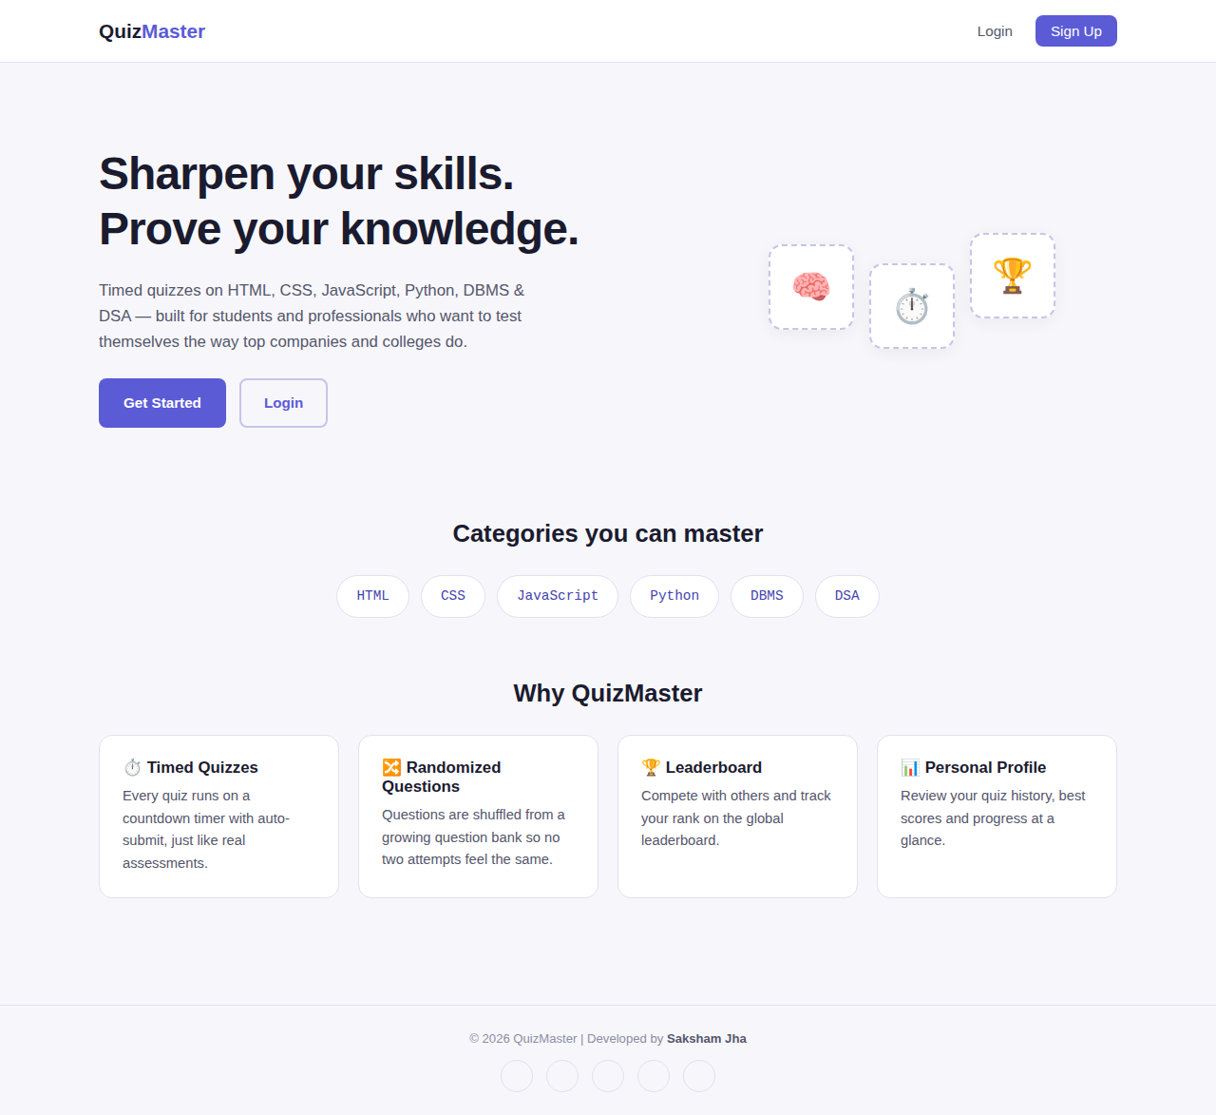
Figure 7.1 — Landing page introducing QuizMaster and its categories

7.2 Login Page
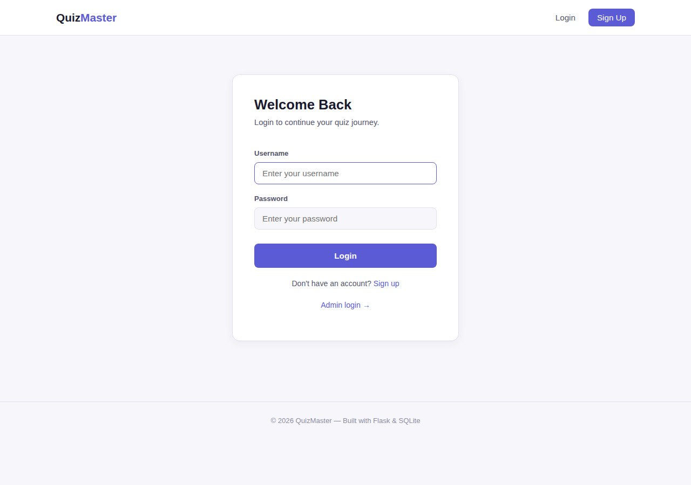
Figure 7.2 — User login page, shared design for both user and admin login

7.3 User Dashboard
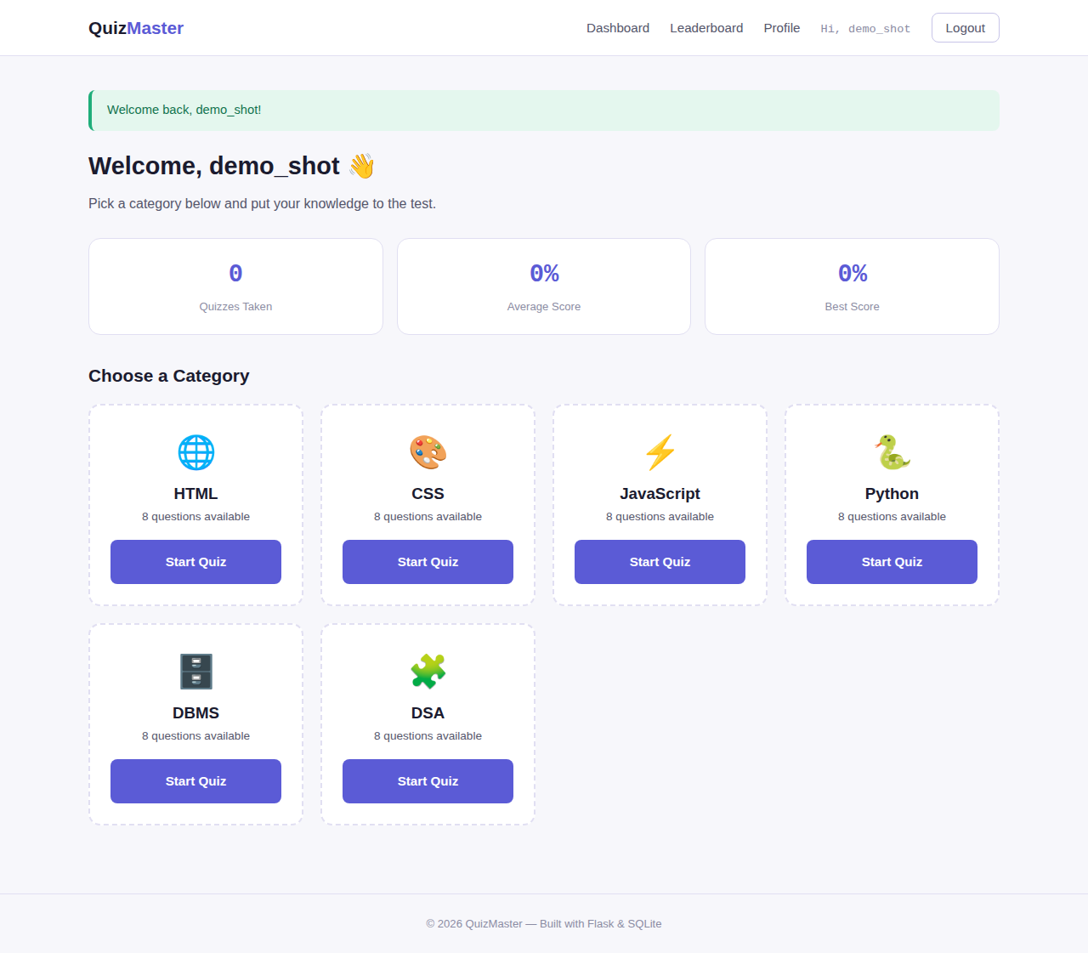
Figure 7.3 — Dashboard with personal stats and category selection cards

7.4 Quiz-Taking Interface
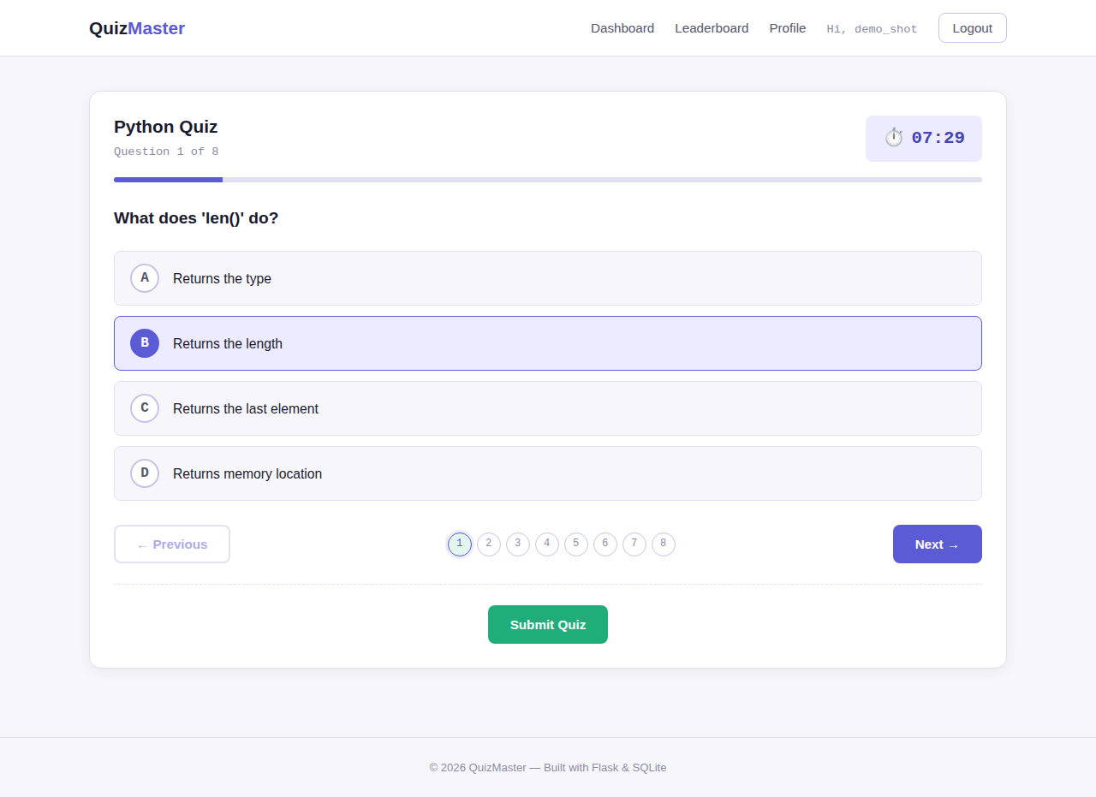
Figure 7.4 — Quiz page showing the scantron-style option bubbles, timer, and progress bar

7.5 Admin Panel
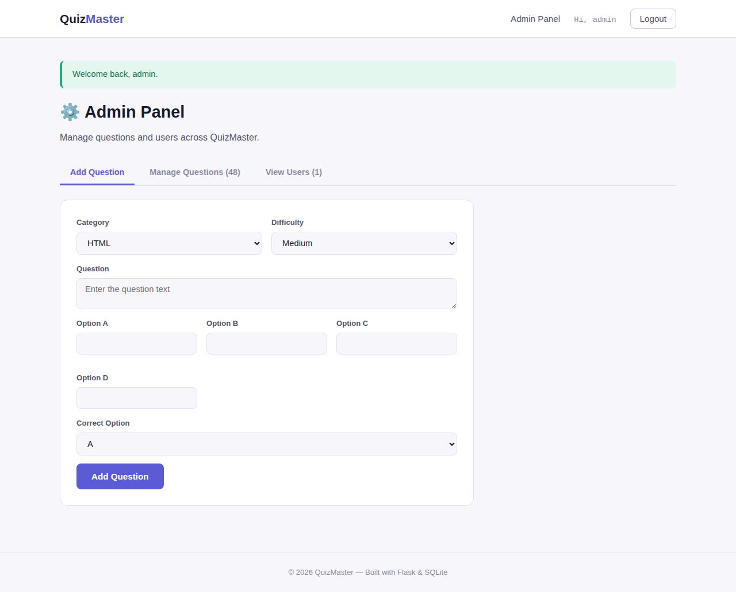
Figure 7.5 — Admin panel for adding and managing questions

7.6 Mobile Responsive View
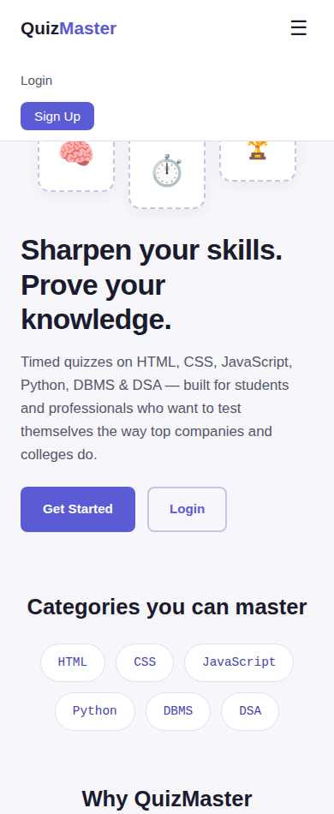
Figure 7.6 — Mobile navigation menu, demonstrating responsive design

8. Testing

8.1 Testing Methodology
The application was tested using a combination of manual exploratory testing and automated functional testing with Flask's built-in test client, simulating a complete user journey — registration, login, quiz attempt, submission, and admin actions — end to end.

8.2 Test Cases
Test Case | Steps | Expected Result | Status
User Registration | Submit register form with valid data | Account created, redirected to login | Pass
Duplicate Registration | Register with an existing username | Error message shown, no duplicate created | Pass
User Login | Submit valid credentials | Session created, redirected to dashboard | Pass
Invalid Login | Submit incorrect password | Error message, access denied | Pass
Fetch Quiz Questions | GET /api/quiz/questions/Python | 10 randomized questions returned, no answers leaked | Pass
Quiz Submission | POST answers to /api/quiz/submit | Score computed correctly, result saved | Pass
Timer Auto-Submit | Let the countdown reach zero | Quiz auto-submits with current answers | Pass
Leaderboard Display | Visit /leaderboard and /leaderboard?category=Python | Correct ranking shown for overall and category views | Pass
Admin Login | Login with admin credentials | Redirected to /admin/dashboard | Pass
Add Question | Submit admin add-question form | New question appears in question bank | Pass
Delete Question / User | Trigger delete action from admin panel | Row removed from database | Pass
Responsive Layout | View site at mobile viewport width | Hamburger nav appears, layout reflows correctly | Pass

9. Results and Discussion
All planned features were implemented and verified working through both automated route testing and manual browser testing (see Chapter 8). The application successfully supports the complete lifecycle of a quiz platform: account creation, timed randomized assessment, automatic grading, historical tracking, and administrative content management.
The scantron-inspired visual design — bubble-style answer options, a monospace question counter, and a dashed “perforated” card border — was well received in review as it reinforces the exam/assessment theme of the application while remaining clean and modern.
One practical limitation observed during deployment was that SQLite's file-based storage is reset on every redeploy when hosted on a free-tier PaaS without a persistent disk. This does not affect local development or short-lived demos, but would need to be addressed (via a persistent disk or a managed database such as PostgreSQL) before any production use with real user data.

10. Future Enhancements
- Migrate to PostgreSQL for persistent, production-grade data storage.
- Add negative marking and configurable quiz length/difficulty per attempt.
- Introduce category-wise difficulty progression and adaptive question selection.
- Add email verification and password-reset flows.
- Support bulk question import via CSV/Excel for administrators.
- Add basic anti-cheating measures such as tab-switch detection during a timed quiz.
- Introduce team/organization accounts for colleges to run cohort-wide assessments.

11. Conclusion
QuizMaster successfully demonstrates a complete, self-contained full-stack web application built with Flask, SQLite, and vanilla JavaScript. It fulfils its core objective of providing a lightweight, customizable, and self-hostable alternative to commercial quiz platforms, while covering the essential features expected of a college-grade or company-style assessment tool: authentication, randomized timed quizzes, automatic grading, leaderboards, user profiles, and an administrative content-management interface.
The project reinforced practical skills in backend routing and session management, relational database schema design, RESTful JSON API design, client-side state management with vanilla JavaScript, and responsive UI design — as well as the operational realities of deploying a Python web application to a cloud platform.

12. References
- Flask Documentation — https://flask.palletsprojects.com/
- Jinja2 Documentation — https://jinja.palletsprojects.com/
- Python sqlite3 Module — https://docs.python.org/3/library/sqlite3.html
- Werkzeug Security Utilities — https://werkzeug.palletsprojects.com/
- MDN Web Docs (HTML/CSS/JavaScript reference) — https://developer.mozilla.org/
- Render Deployment Documentation — https://render.com/docs
- Railway Deployment Documentation — https://docs.railway.app/

